|  |  |
| --- | --- |
|  | **FPT ACADEMY INTERNATIONAL**  **FPT – APTECH COMPUTER EDUCATION** |

**Centre Name: ACE-HCMC-2-FPT.**

**Address: 590 Cach Mang Thang 8 , District 3, Ho Chi Minh City, Viet Nam.**

Online Auction

**Design Document**

|  |  |  |
| --- | --- | --- |
| **Supervisor:** | Mr. TRAN PHUOC SINH | |
| **Semester:** | 3 | |
| **Batch No:** | T1.2008.A0 | |
| **Group No:** | 3 | |
| **Order:** | **Full name** | **Roll No.** |
| 1. | PHAN PHUC THINH | Student1275061 |
| 2. | NGUYEN THI MINH THU | Student1273010 |
| 3. | TRAN HOANG QUOC TAI | Student1273014 |
| 4. | VO THI KIM DUNG | Student1275249 |

**Month**: December **Year**: 2022

1. **Software and Hardware Requirement**
2. **Hardware requirement**

|  |  |
| --- | --- |
| Component | Requirement |
| Server | Processor type:  Pentium III-compatible processor or faster  Processor speed:  Recommended: 2.0 GHz or faster |
| OS | Microsoft Windows Server 2003 or higher |
| Memory (RAM) | RAM:  Minimum: 512 MB  Recommended: 2.048 GB or more  Maximum: Operating system maximum |
| Hard Drive | Free space:  Minimum: 50 MB  Recommended: 50 GB or more  Maximum: Operating system maximum |

1. **Software requirement**

|  |  |
| --- | --- |
| Component | Requirement |
| Microsoft .NET Framework | Version 4.5.x |
| Microsoft Visual Studio | Microsoft Visual Studio 2019 |
| Hosting | IIS 8.0 or higher |
| Web Browser | Chrome (recommended), Firefox, IE 7 or higher |

1. **Configuration**
2. **Database Configuration**

* Open and Connect Microsoft SQL Server Management Studio 2019

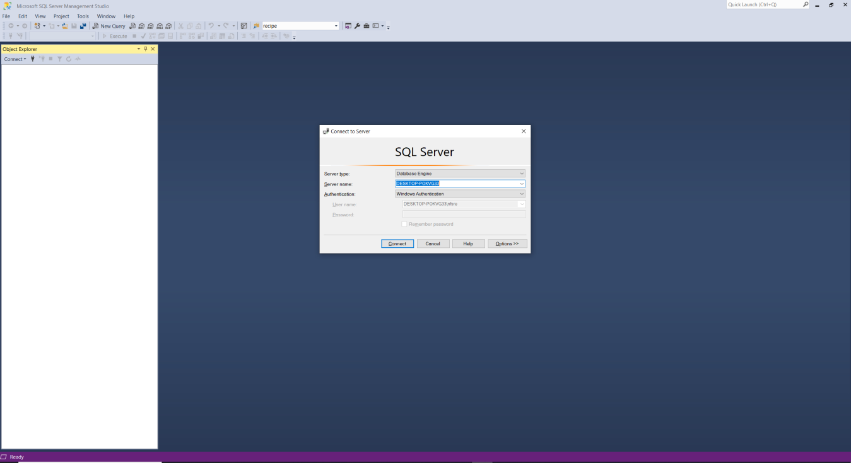

* 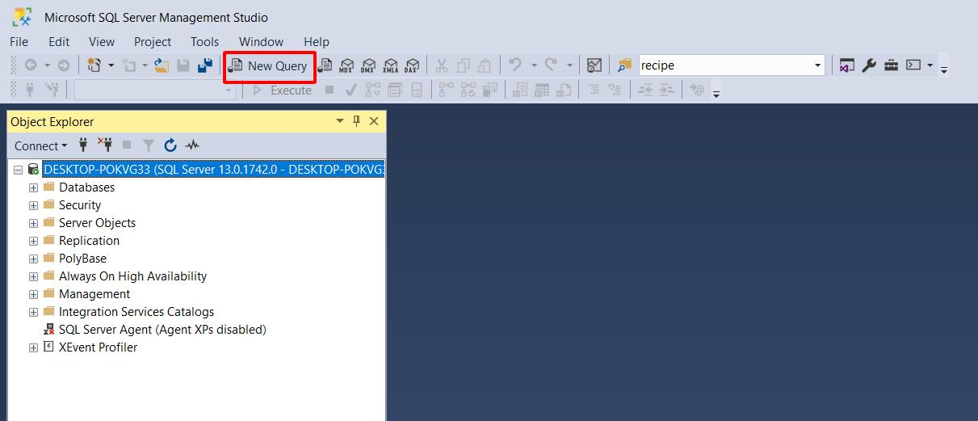Click New Query
* Open folder OnlineAuction> eProject

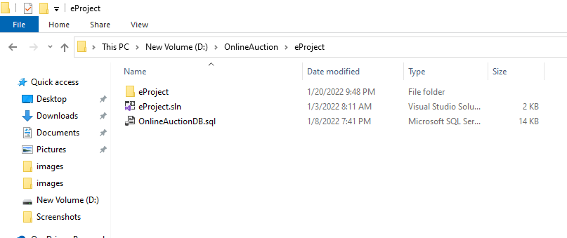

* Open OnlineAuctionDB database file by Microsoft SQL Server Management

Studio 19:

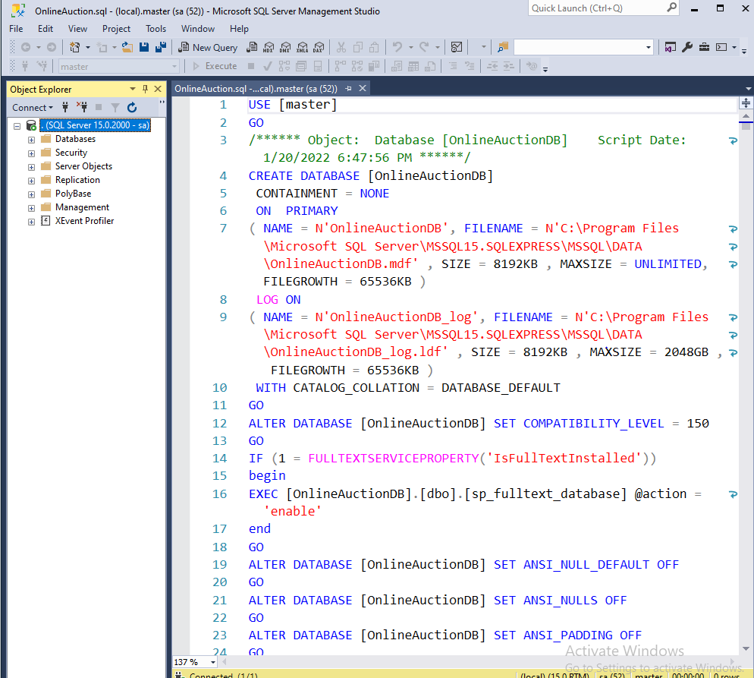

* Ctrl A and F5 to insert database OnlineAuctionDB:

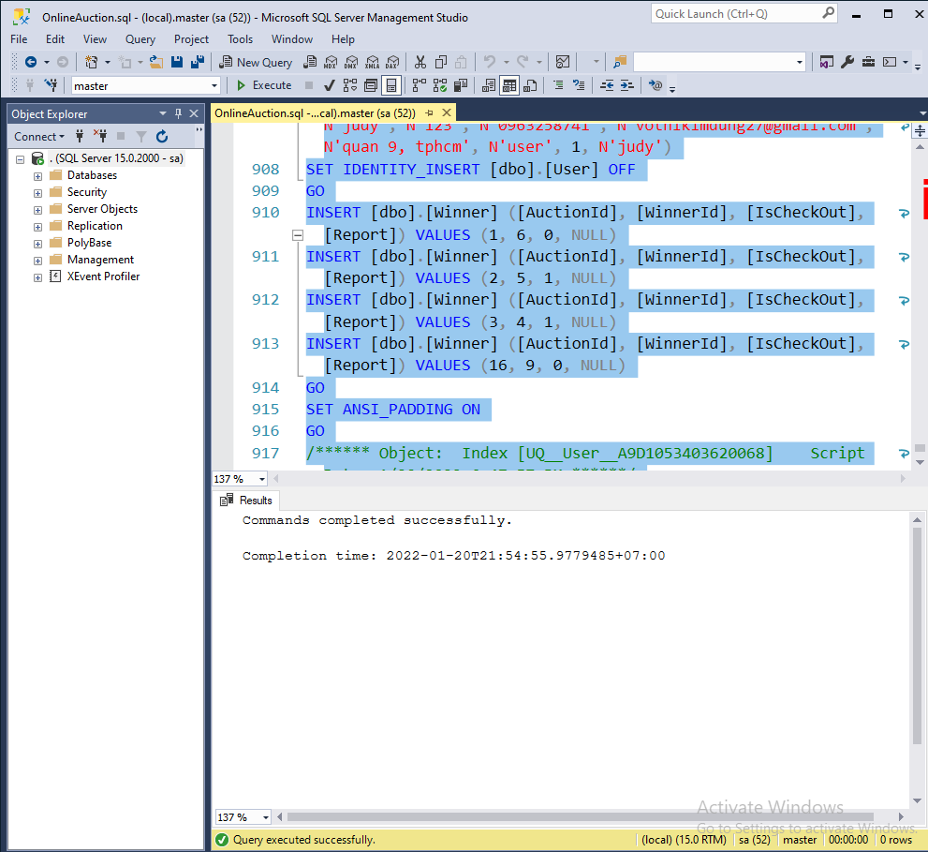

* Refesh database:

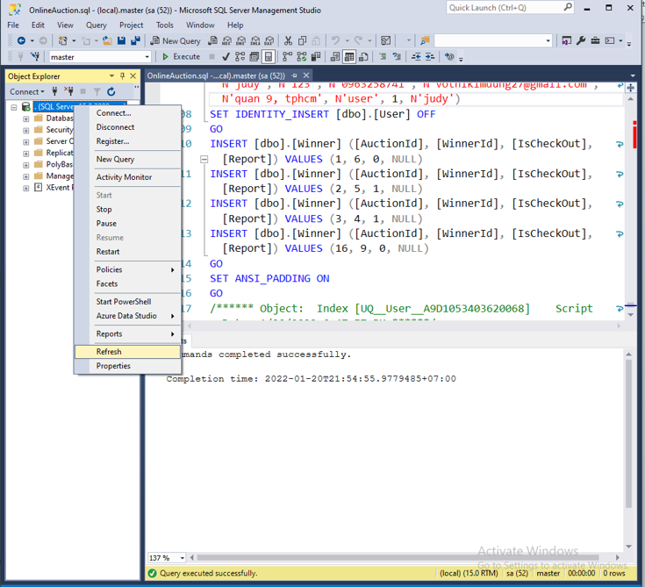

* The name of database OnlineAuctionDBwill be displayed.

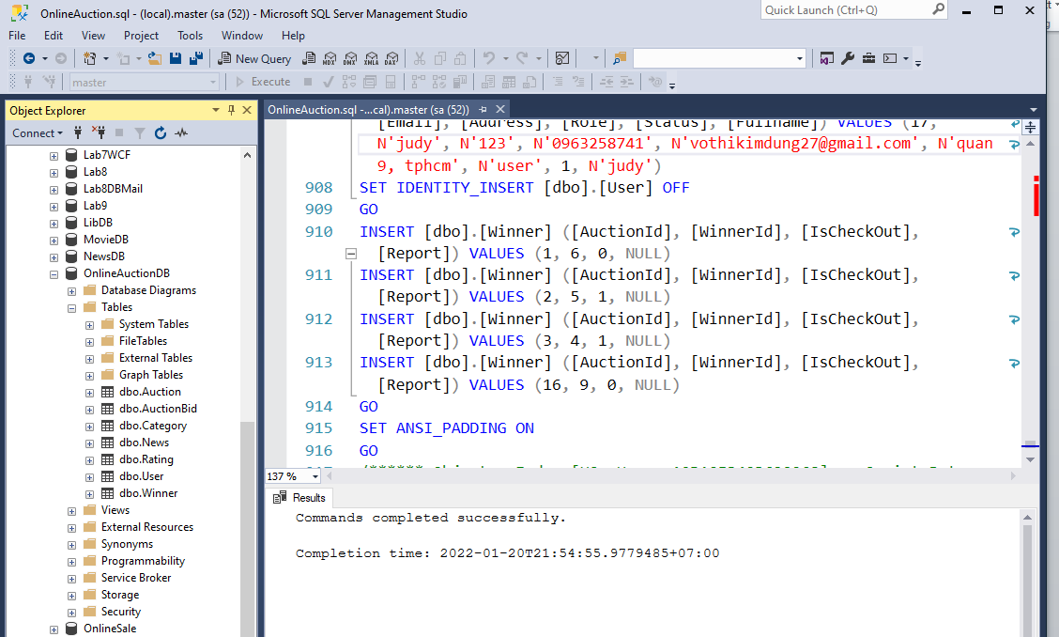

1. **Open Project**

* Locate ***eProject*** solution file in OnlineAuction / eProject folder.
* Double-click on ***eProject.sln*** to open project in Microsoft Visual Studio 2019

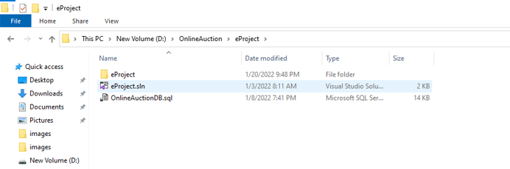

2.2 In Microsoft Visual Studio, Expand ***eProject*** project, open ***appsetting.json***

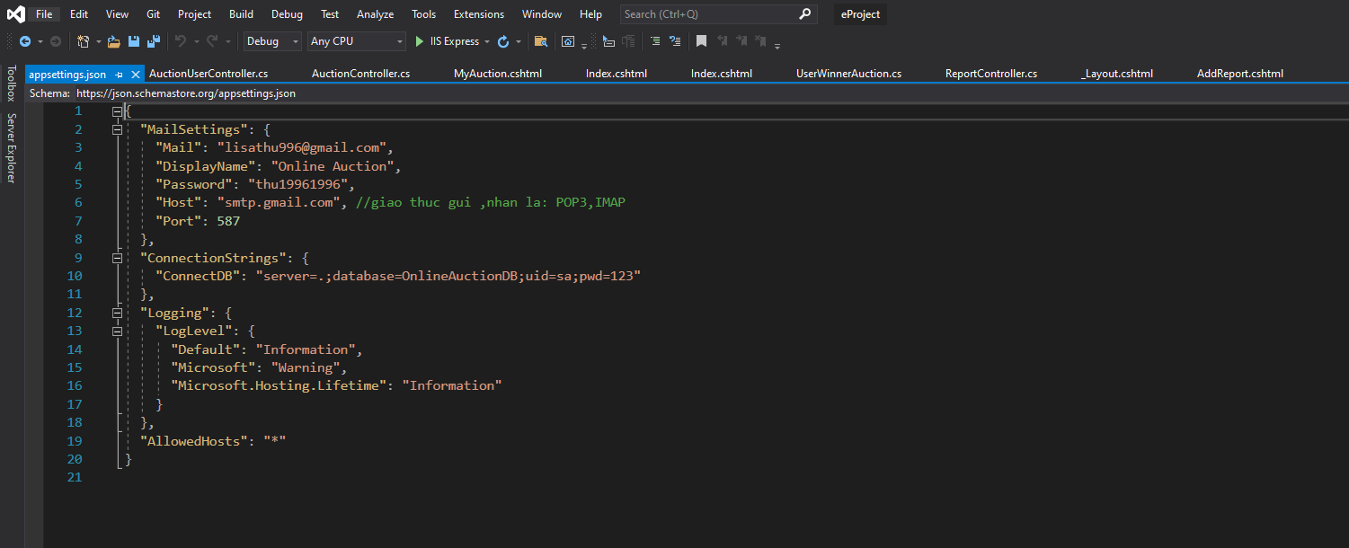

Inline:

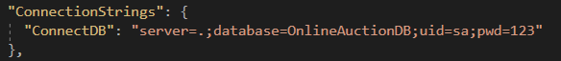

Edit “***ConnectionStrings***” if you want to change the name of database.

* server: SQL Server name (Example: “.”))
* uid: Username to log on SQL Server (Example: “sa”)
* password: Password to log on SQL Server (Example:”123”)

2.3 In Microsoft Visual Studio, click on menu Build and select Build Solution

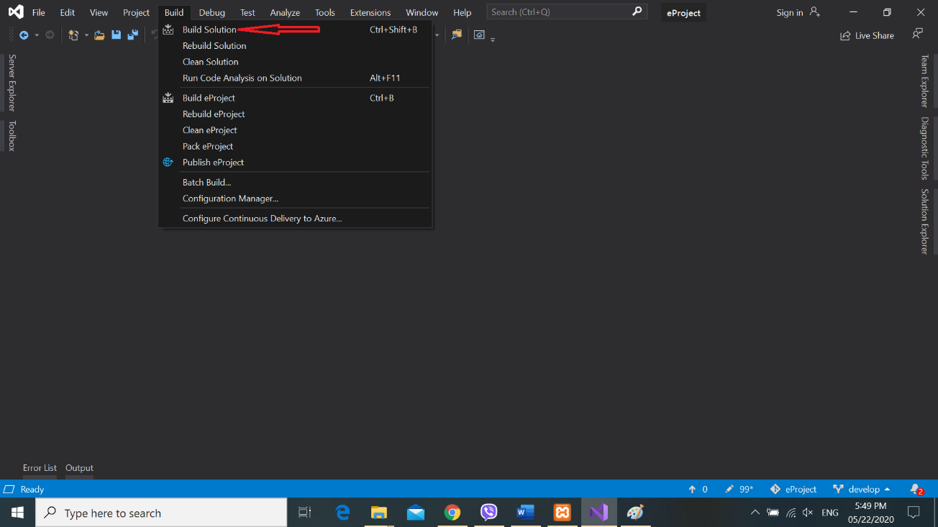

2.4 Wait for Successful message:

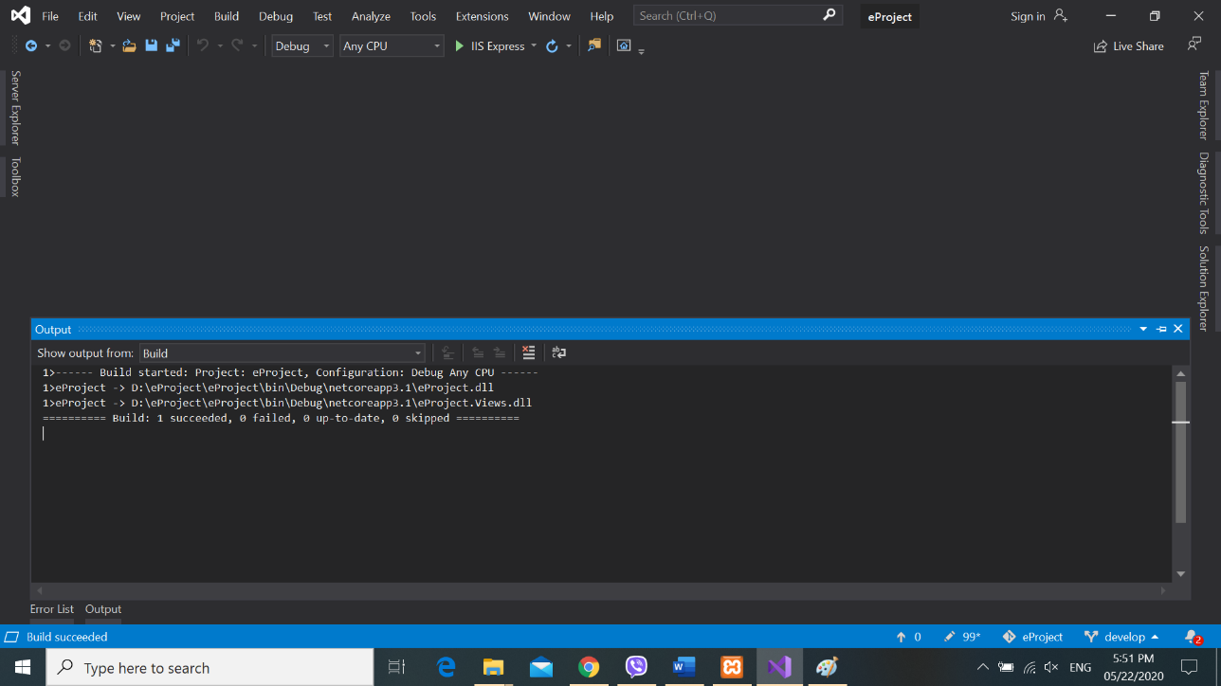

* 1. Click on IIS Express button and the website is ready.

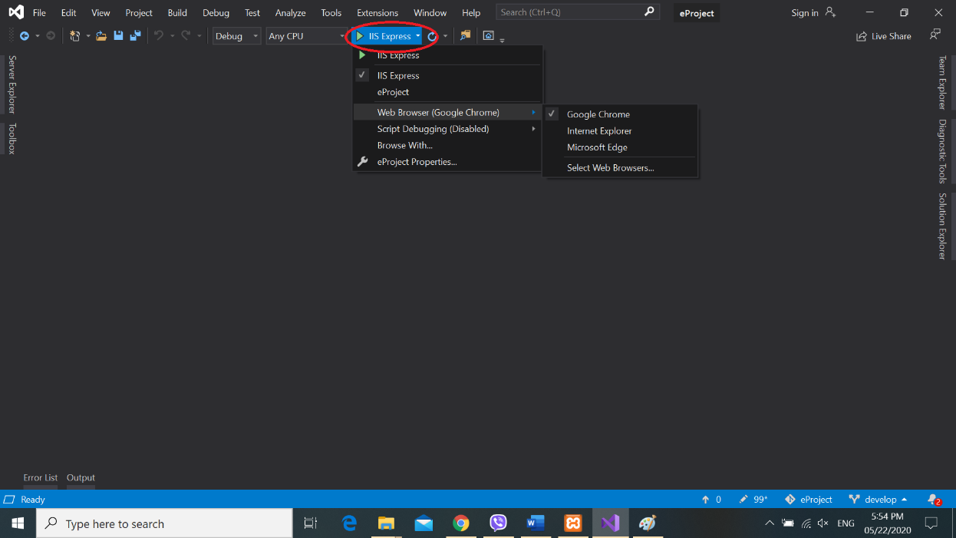

So you have finished the installation of our software. Congratulations on that. We are very honored to be able to guide you, thank you for keeping track!!

Note: You can use the accounts below to test:

1. Seller account : [seller@gmail.com](mailto:seller@gmail.com). Password : 123
2. Buyer account : [thinh@gmail.com](mailto:thinh@gmail.com) . Password: 123
3. Admin account : [admin@gmail.com](mailto:admin@gmail.com) . Password: 123